**Fanka Shundovska**

**POSTMAN Homework 4**

* We will use the request from RestfullBooker to automate them by the following order:
* **POST**/ Authenticate – Create Token

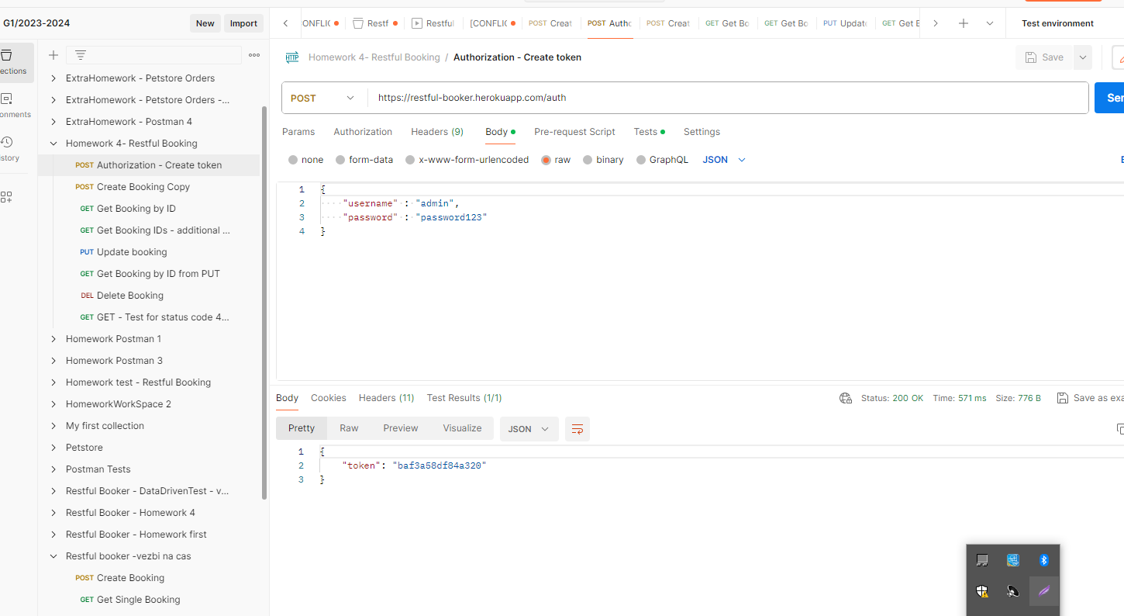

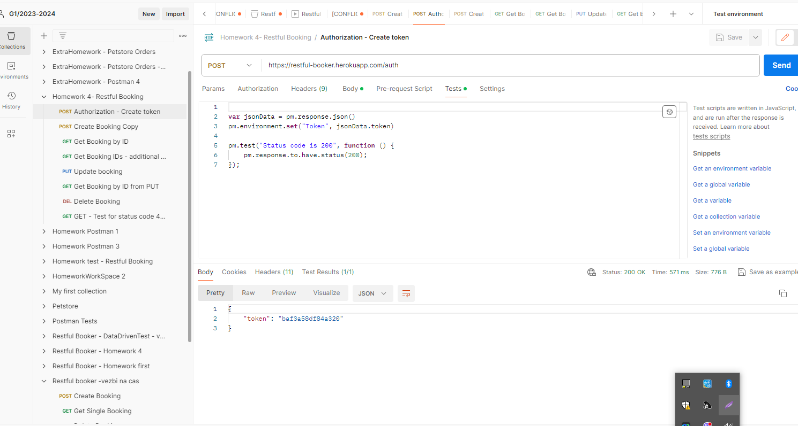

* **POST**/ CreateBooking - Tests for status code, firstname, lastname, total price and additionalNeeds.

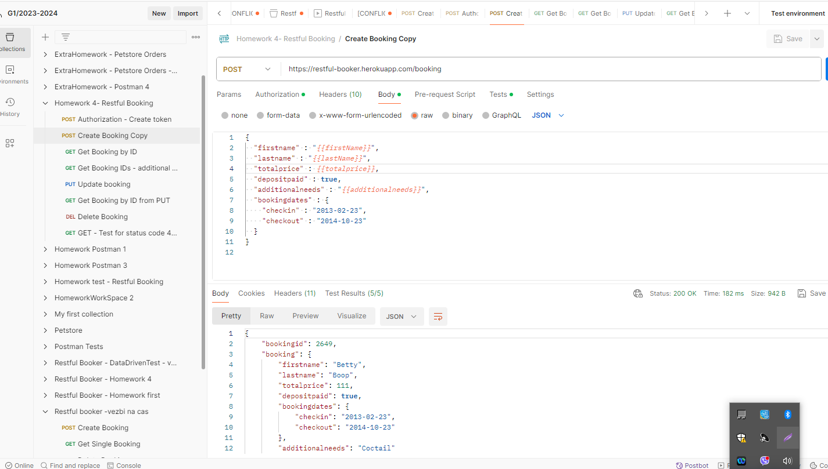

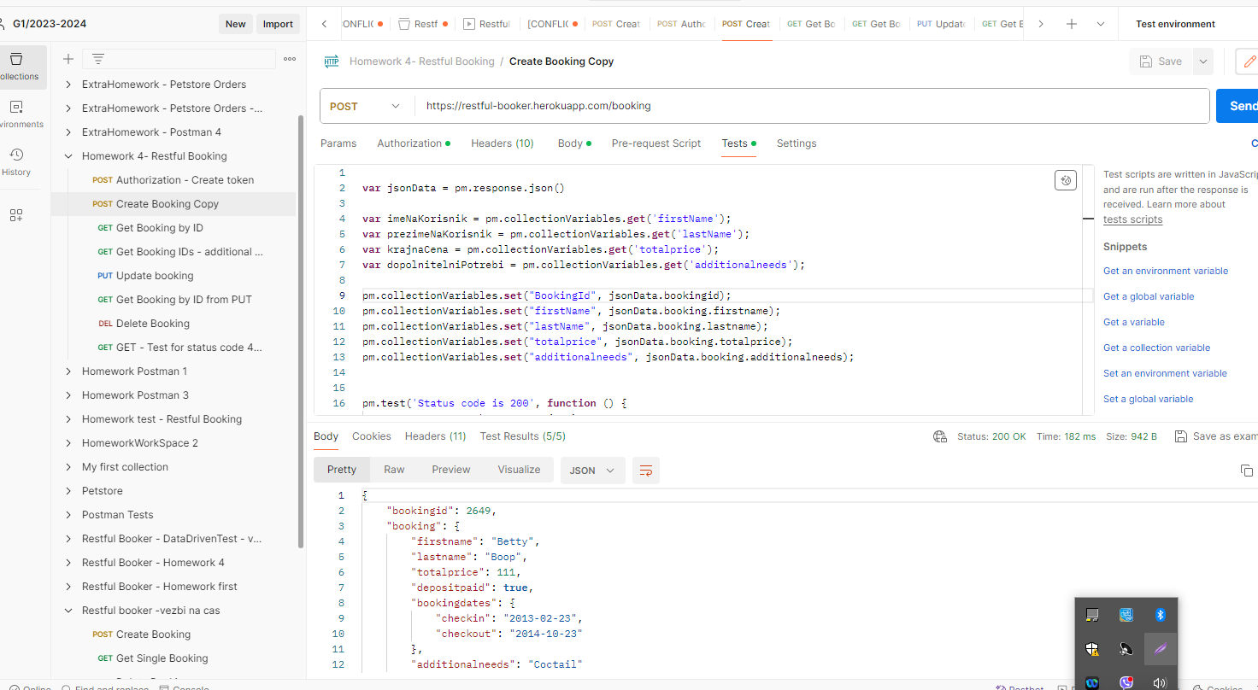

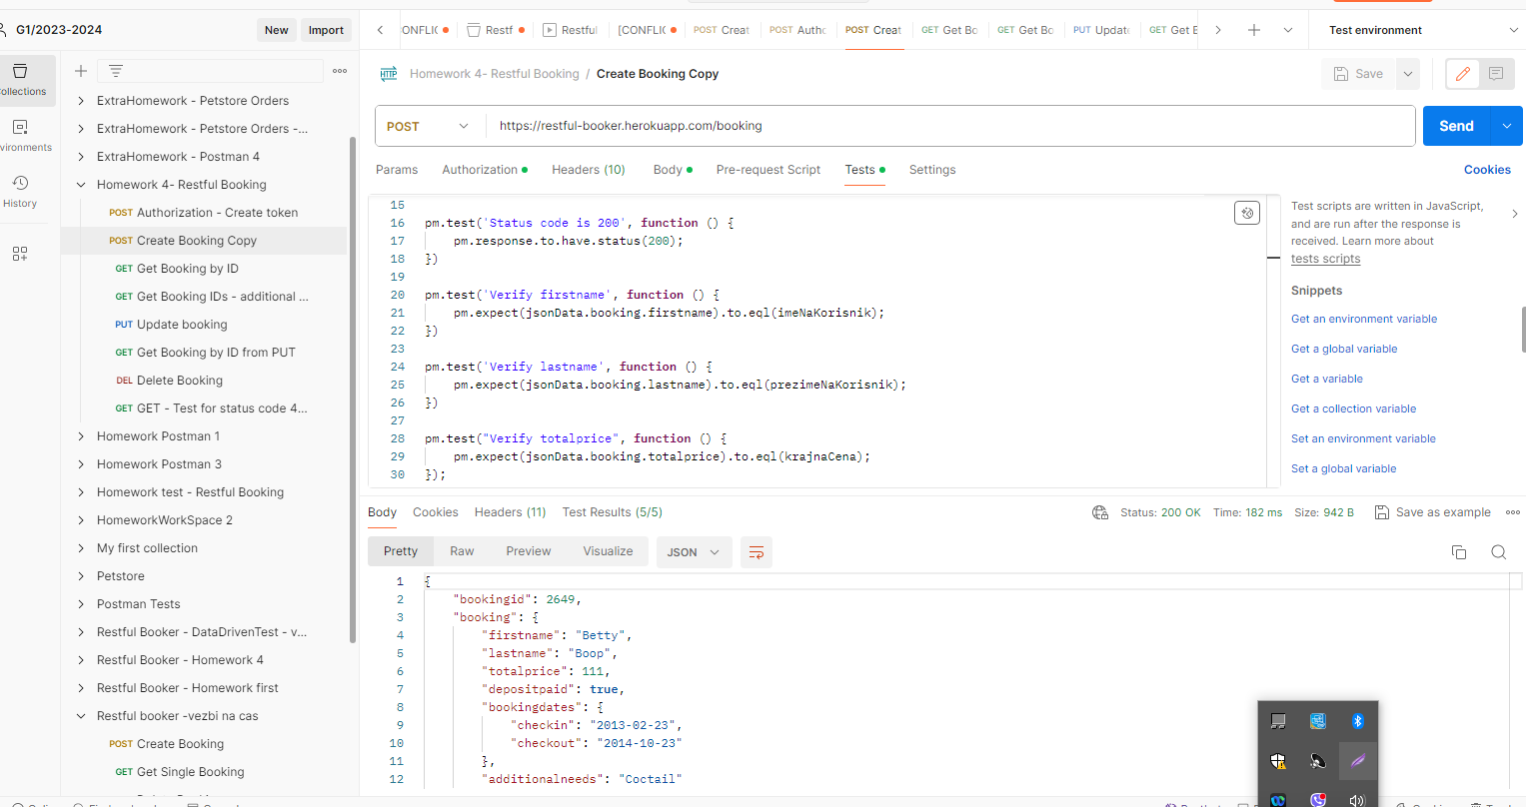

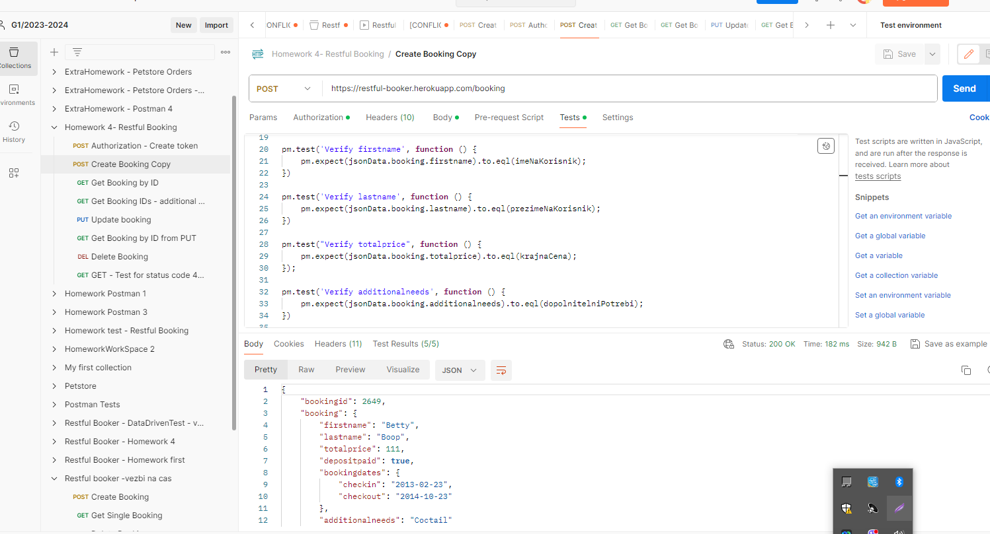

* **GET**/ Booking by id- tests for status code firstname, lastname, total price and additionalNeeds.

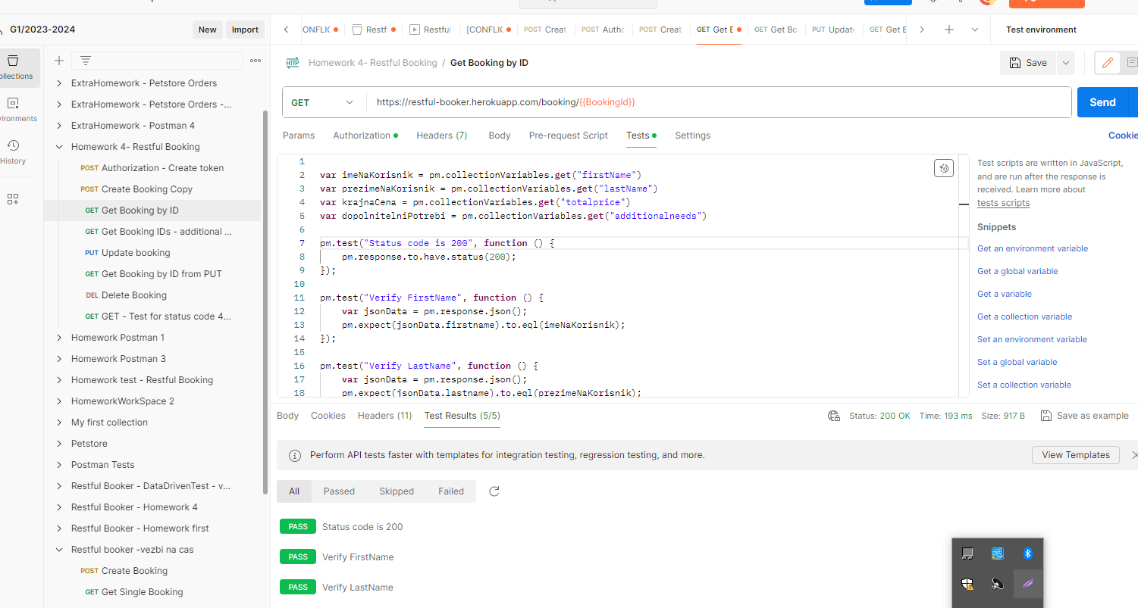

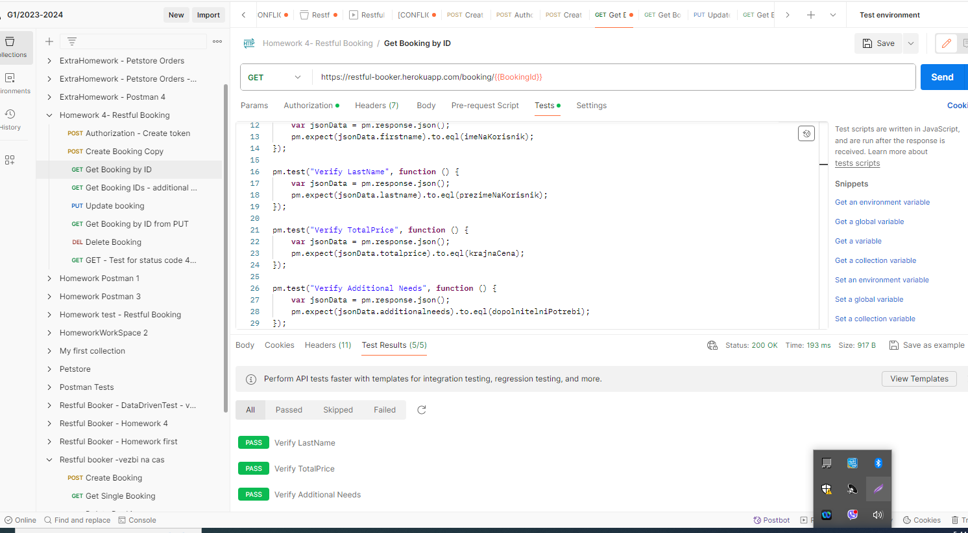

* **PUT**/Update booking by id - Tests for status code, firstname lastName, total price and additionalNeeds.

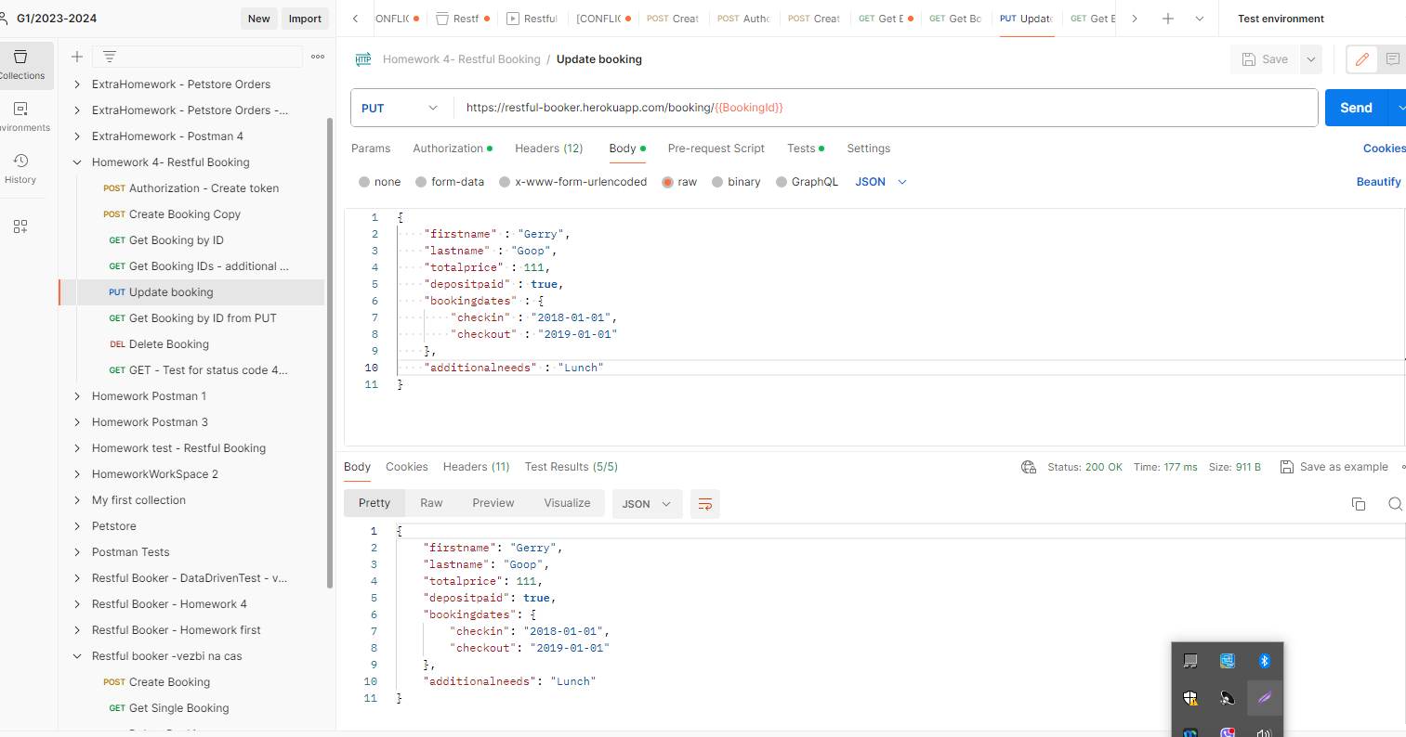

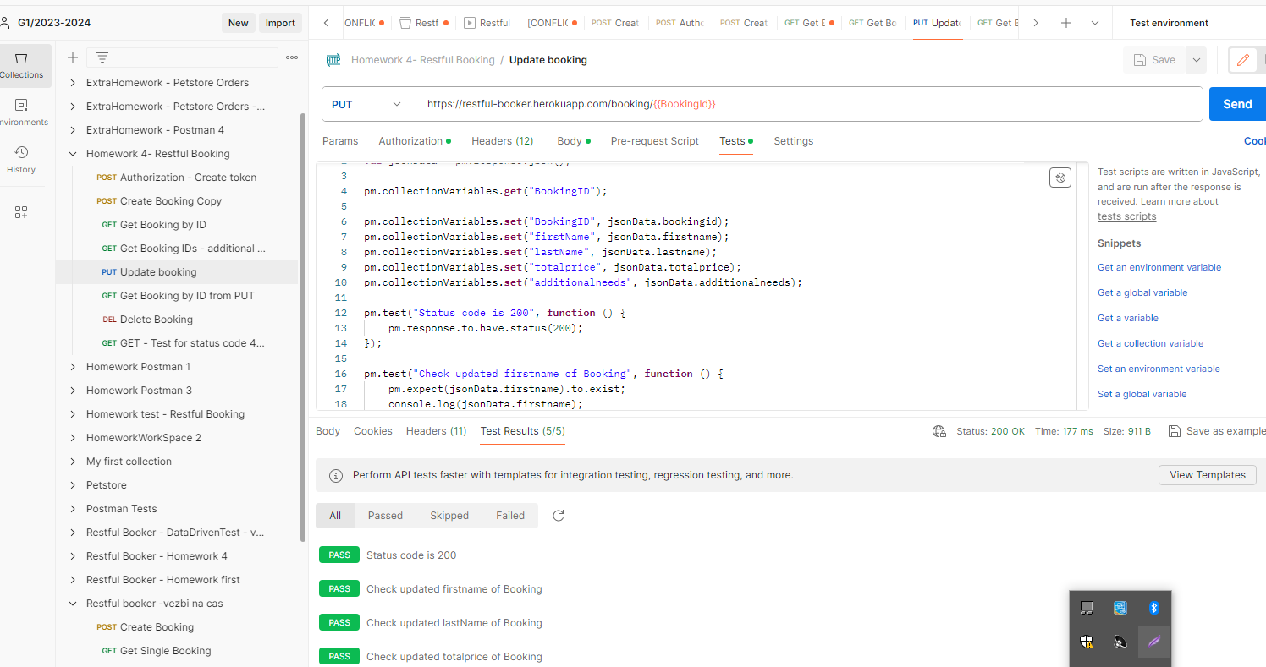

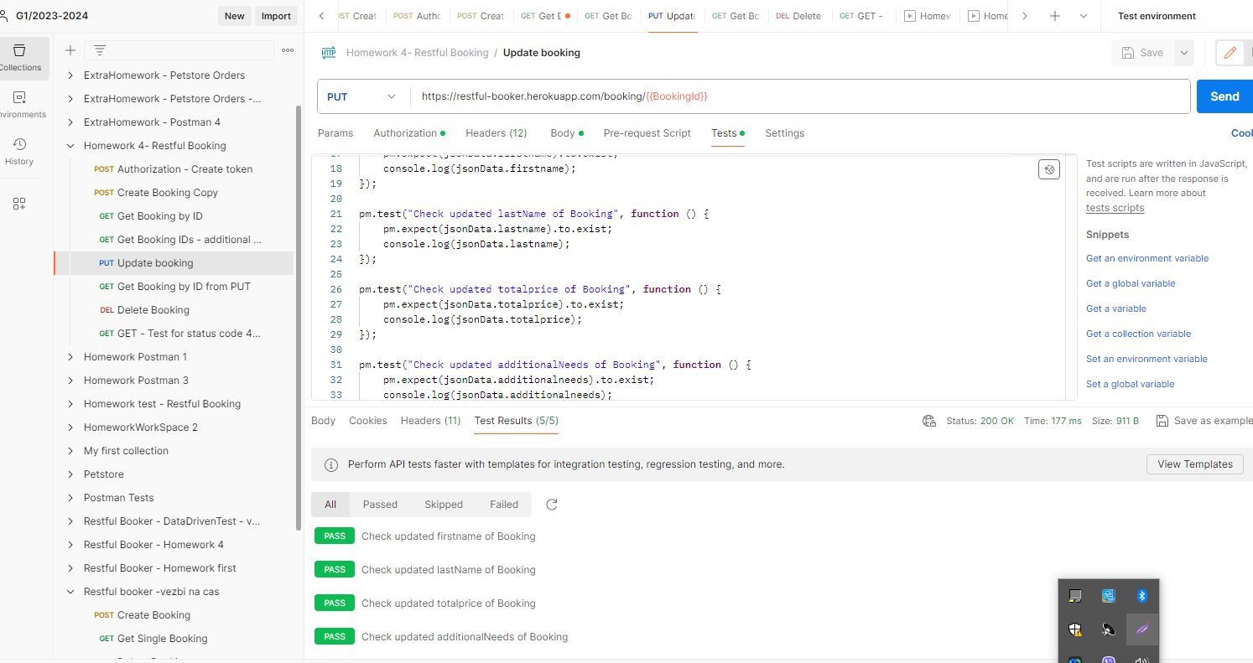

* **GET**/Booking by id - tests for status code, firstname,lastName,totalprice and additionalNeeds made from the PUT request.



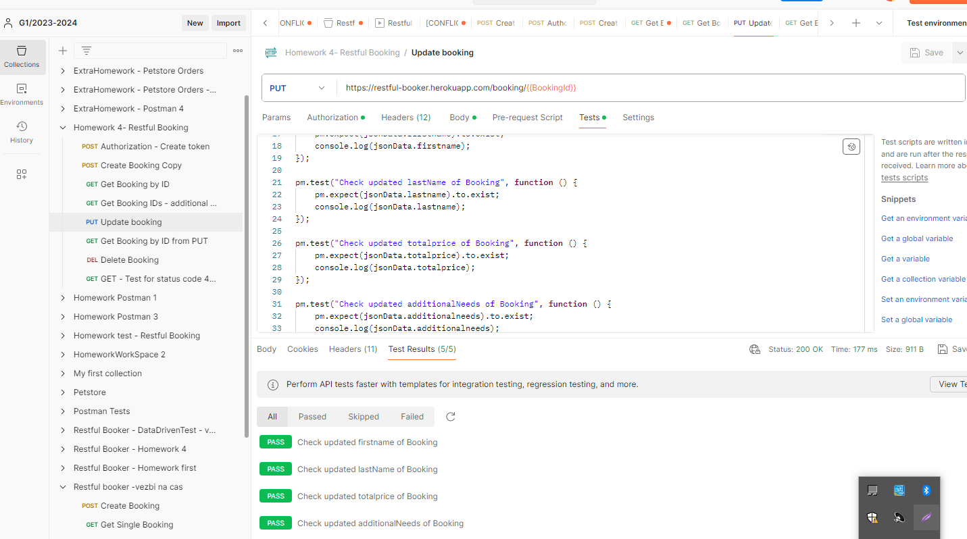

* **DELETE**/Booking by id - test for status code(201)

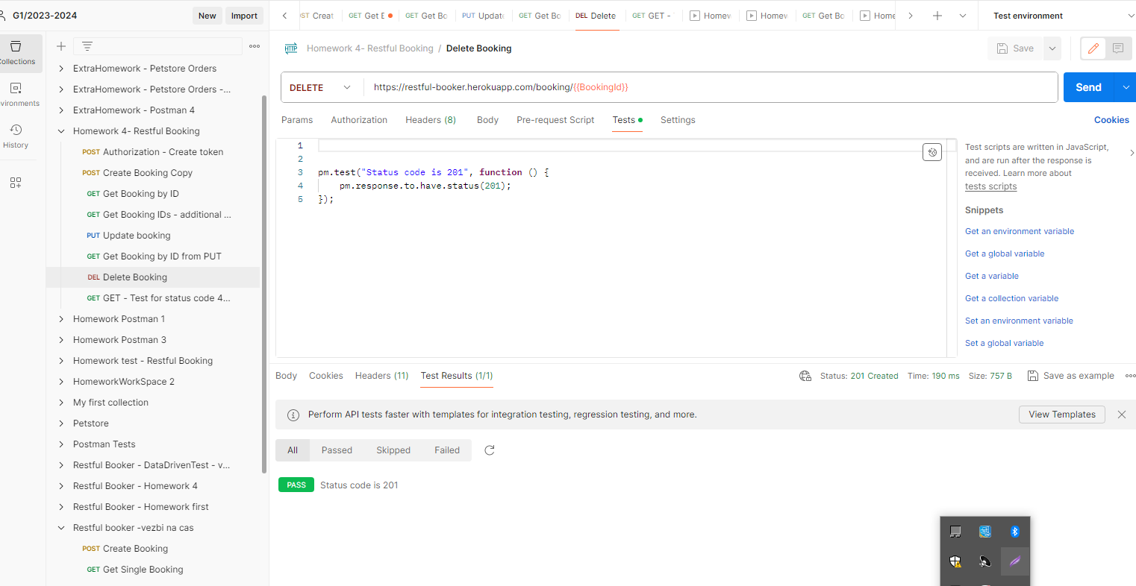

* **GET**/Booking by id - test for status code (404)

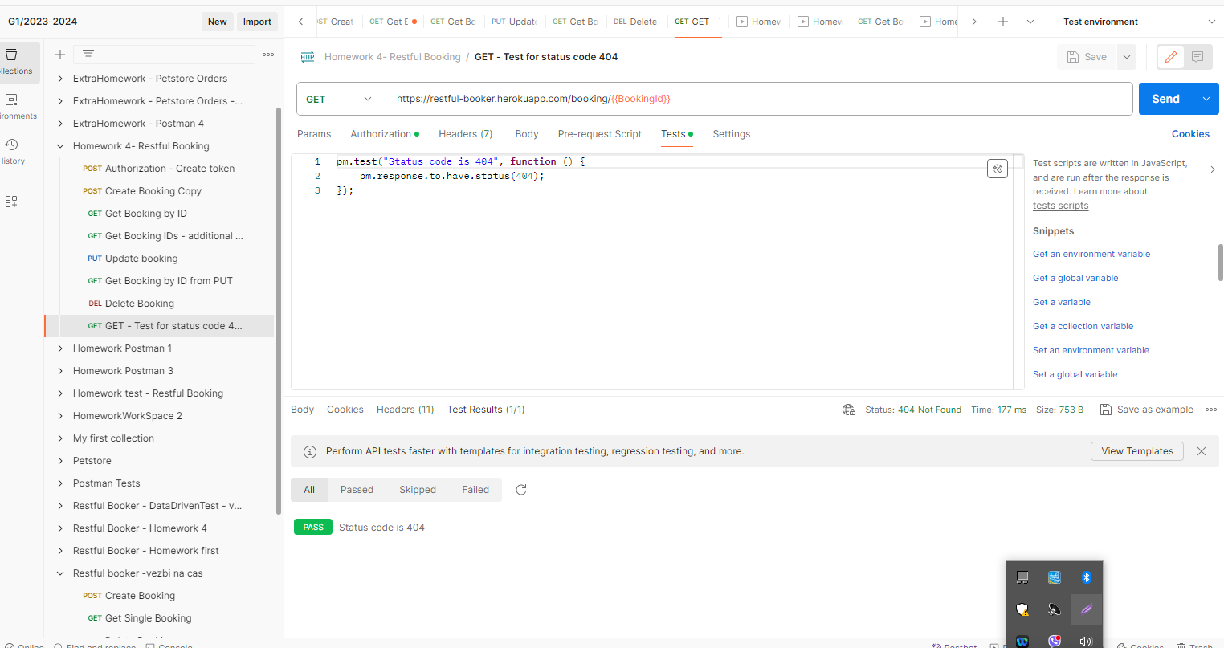

* Homework 4 - Run

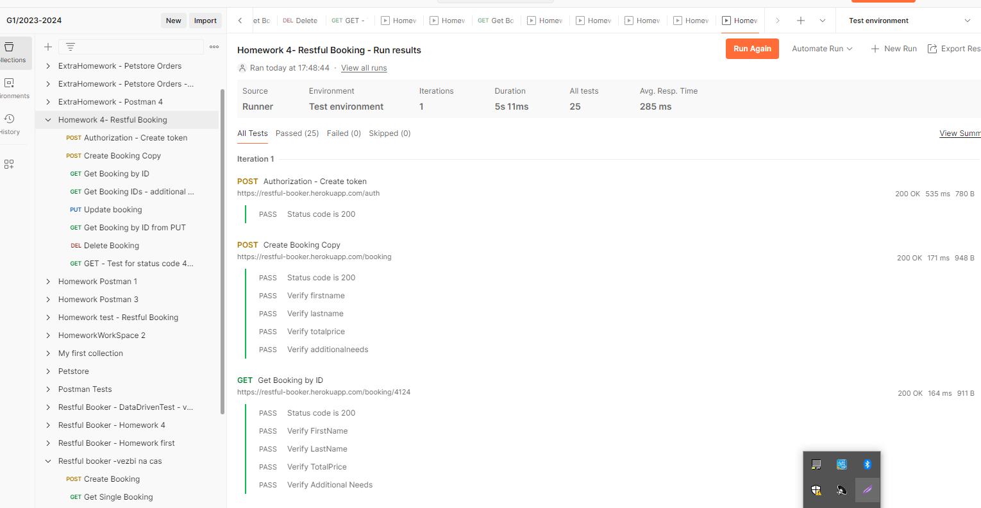

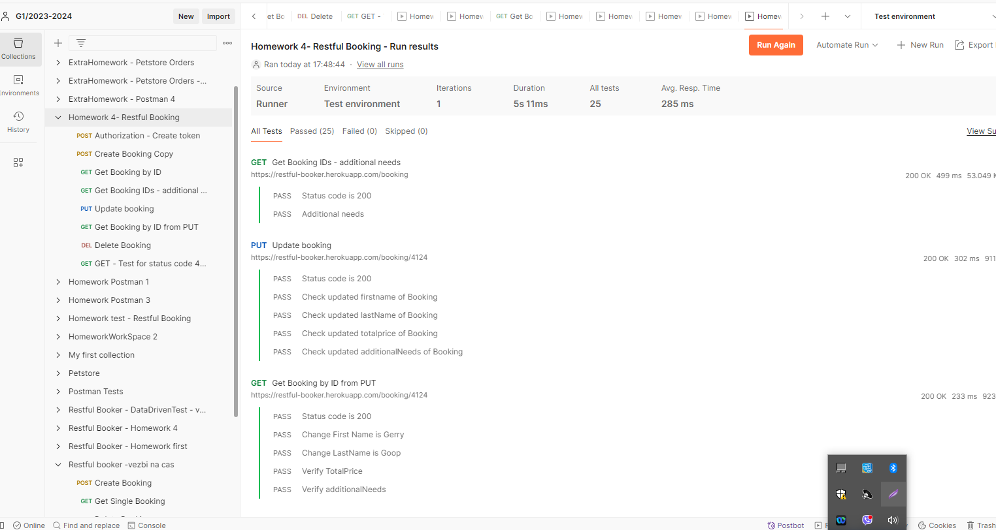

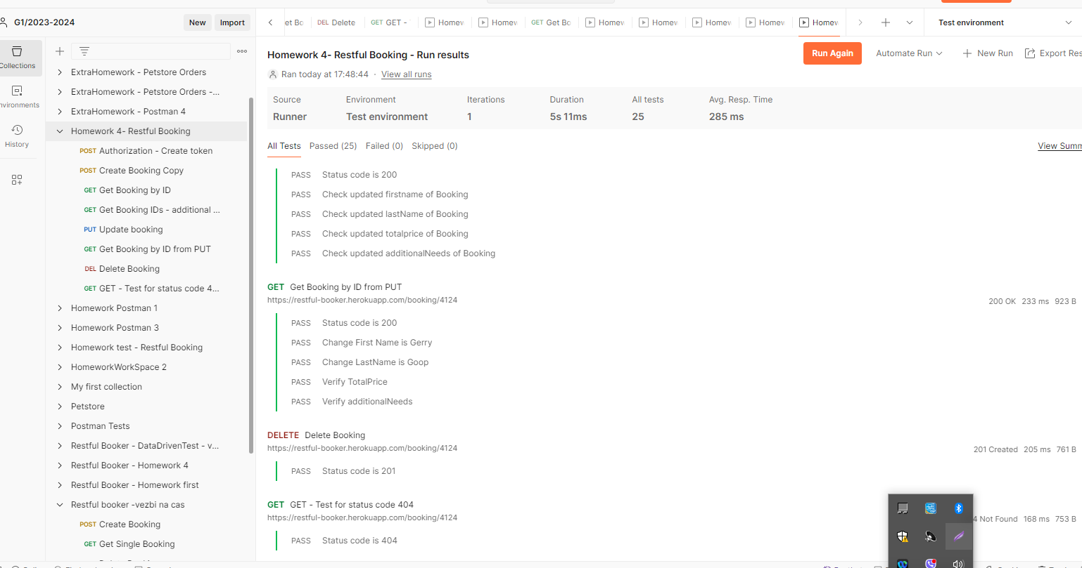

* **Note**: some of the requests are using authorization, we can authenticate via the Authentication request or passing Basic Authorization with username and password.